UNITED STATES
SECURITIES AND EXCHANGE COMMISSION
Washington, D.C. 20549

SCHEDULE 14A

Proxy Statement Pursuant to Section 14(a) of the
Securities Exchange Act of 1934
(Amendment No.)

Filed by the Registrant ☒
Filed by a party other than the Registrant ☐

Check the appropriate box:

☐ | Preliminary Proxy Statement
☐ | Confidential, for use of the Commission Only (as permitted by Rule 14a-6(e)(2))
☐ | Definitive Proxy Statement
☒ | Definitive Additional Materials
☐ | Soliciting Material Pursuant to §240.14a-12

Marker Therapeutics, Inc.
(Name of Registrant as Specified In Its Charter)

(Name of Person(s) Filing Proxy Statement, if Other Than the Registrant)

Payment of Filing Fee (Check the appropriate box):

☒ | No Fee Required
☐ | Fee paid previously with preliminary materials.
☐ | Fee computed on table in exhibit required by Item 25(b) per Exchange Act Rules 14a-6(i)(1) and 0-11


Get informed before you vote *If you choose to vote these shares in person at the meeting, you must request a “legal proxy.” To do so, please follow the instructions at www.ProxyVote.com or request a paper copy of the materials, which will contain the appropriate instructions. Please check the meeting materials for any special requirements for meeting attendance. Smartphone users Point your camera here and vote without entering a control number Your Vote Counts! FLASHID-JOB# For complete information and to vote, visit www.ProxyVote.com Control # Ricky Campana P.O. Box 123456 Suite 500 51 Mercedes Way Edgewood, NY 11717 148,294 322,224 1 OF 2 30# Hextone, Inc. P.O. Box 9142 Farmingdale, NY 11735 XXXX XXXX XXXX XXXX MARKER THERAPEUTICS, INC. 2026 Annual Meeting Vote by April 30, 2026 11:59 PM ET You invested in MARKER THERAPEUTICS, INC. and it's time to vote! You have the right to vote on proposals being presented at the Annual Meeting. This is an important notice regarding the availability of proxy material for the shareholder meeting to be held on May 01, 2026. View the Proxy Statement, Annual Report online OR you can receive a free paper or email copy of the material(s) by requesting prior to April 19, 2026. If you would like to request a copy of the material(s) for this and/or future shareholder meetings, you may (1) visit www.ProxyVote.com, (2) call 1-800-579-1639 or (3) send an email to sendmaterial@proxyvote.com. If sending an email, please include your control number (indicated below) in the subject line. Unless requested, you will not otherwise receive a paper or email copy. Vote in Person at the Meeting* May 01, 2026 9:00 AM CST Annual Meeting to be held virtually Beneficial Holder at the below URL: https://web.viewproxy.com/markertherapeutics/2026AM
 | 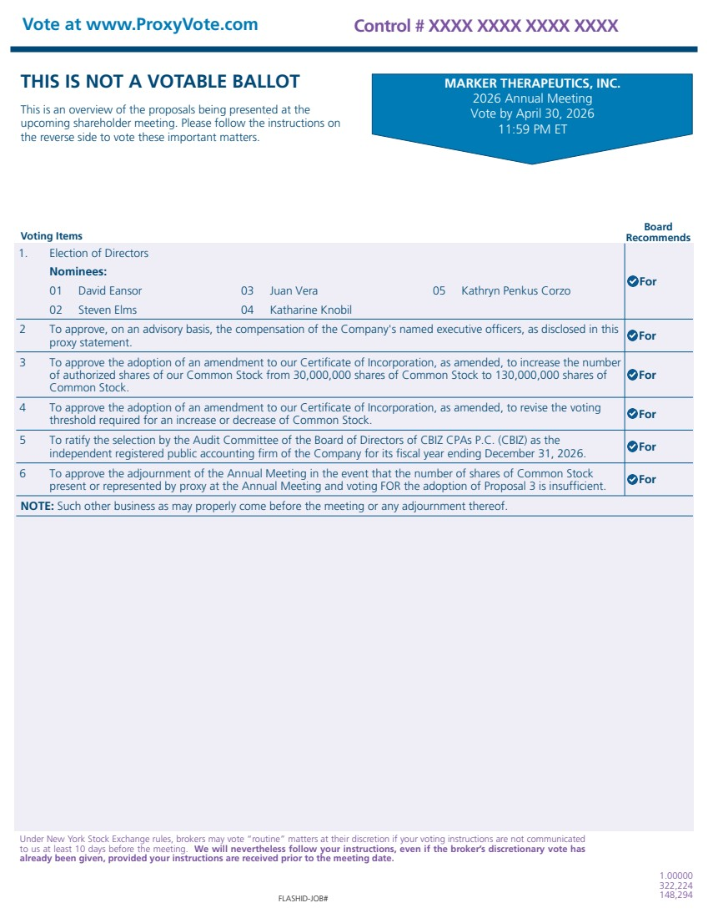 | Voting Items Board Recommends THIS IS NOT A VOTABLE BALLOT This is an overview of the proposals being presented at the upcoming shareholder meeting. Please follow the instructions on the reverse side to vote these important matters. Vote at www.ProxyVote.com FLASHID-JOB# Control # XXXX XXXX XXXX XXXX 1.00000 322,224 148,294 Under New York Stock Exchange rules, brokers may vote “routine” matters at their discretion if your voting instructions are not communicated to us at least 10 days before the meeting. We will nevertheless follow your instructions, even if the broker’s discretionary vote has already been given, provided your instructions are received prior to the meeting date. MARKER THERAPEUTICS, INC. 2026 Annual Meeting Vote by April 30, 2026 11:59 PM ET 1. Election of Directors Nominees: 01 David Eansor 03 Juan Vera 05 Kathryn Penkus Corzo 02 Steven Elms 04 Katharine Knobil For 2 To approve, on an advisory basis, the compensation of the Company's named executive officers, as disclosed in this proxy statement. For 3 To approve the adoption of an amendment to our Certificate of Incorporation, as amended, to increase the number of authorized shares of our Common Stock from 30,000,000 shares of Common Stock to 130,000,000 shares of Common Stock. For 4 To approve the adoption of an amendment to our Certificate of Incorporation, as amended, to revise the voting threshold required for an increase or decrease of Common Stock. For 5 To ratify the selection by the Audit Committee of the Board of Directors of CBIZ CPAs P.C. (CBIZ) as the independent registered public accounting firm of the Company for its fiscal year ending December 31, 2026. For 6 To approve the adjournment of the Annual Meeting in the event that the number of shares of Common Stock present or represented by proxy at the Annual Meeting and voting FOR the adoption of Proposal 3 is insufficient. For NOTE: Such other business as may properly come before the meeting or any adjournment thereof.

